Lab Taks-5

Submission Guidelines-
- Rename the file with your serial number only
- Must submit within the announced time.
- Must include resources for all the section in the table
Question-1
Create an animation using two box that will move in the opposite direction.
Graph Plot (Picture)- 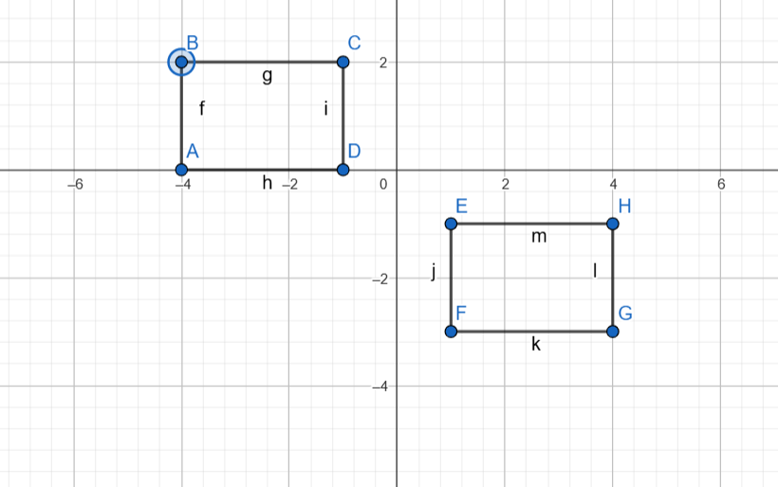

Code-
#include <GL/glut.h>

struct Box {
float x, y; // Center position
float width, height;
float speed;
int direction;
float color[3];
const char* label;
};

// Initialize boxes with same speed but opposite directions
Box box1 = {-3.0f, 1.0f, 2.0f, 1.5f, 0.03f, 1, {0.8f, 0.2f, 0.0f}, "A"}; // Orange box moving right
Box box2 = {3.0f, -1.0f, 2.0f, 1.5f, 0.03f, -1, {0.0f, 0.6f, 0.8f}, "B"}; // Teal box moving left

void drawText(float x, float y, const char* text) {
glRasterPos2f(x, y);
while (*text) {
glutBitmapCharacter(GLUT_BITMAP_HELVETICA_12, *text++);
}
}

void drawBox(const Box& box) {
glColor3fv(box.color);
glBegin(GL_QUADS);
glVertex2f(box.x - box.width/2, box.y - box.height/2);
glVertex2f(box.x + box.width/2, box.y - box.height/2);
glVertex2f(box.x + box.width/2, box.y + box.height/2);
glVertex2f(box.x - box.width/2, box.y + box.height/2);
glEnd();

// Draw label at box center
glColor3f(1.0f, 1.0f, 1.0f);
drawText(box.x - 0.1f, box.y, box.label);
}

void update(int value) {
// Move both boxes at same speed in opposite directions
box1.x += box1.speed * box1.direction;
box2.x += box2.speed * box2.direction;

// Boundary checking - bounce when edges hit boundaries
if (box1.x + box1.width/2 > 7.0f || box1.x - box1.width/2 < -7.0f) {
box1.direction *= -1;
}
if (box2.x + box2.width/2 > 7.0f || box2.x - box2.width/2 < -7.0f) {
box2.direction *= -1;
}

glutPostRedisplay();
glutTimerFunc(16, update, 0); // 60 FPS
}

void display() {
glClear(GL_COLOR_BUFFER_BIT);

// Draw title and info
//glColor3f(1.0f, 1.0f, 1.0f);
//drawText(-1.5f, 2.5f, "Synchronized Box Movement");
//drawText(-3.0f, -2.8f, "Both boxes moving at speed: 0.03");

drawBox(box1);
drawBox(box2);

glutSwapBuffers();
}

void init() {
glClearColor(0.15f, 0.15f, 0.15f, 1.0f); // Dark background
glMatrixMode(GL_PROJECTION);
glLoadIdentity();
gluOrtho2D(-8.0, 8.0, -3.5, 3.5);
}

int main(int argc, char** argv) {
glutInit(&argc, argv);
glutInitDisplayMode(GLUT_DOUBLE | GLUT_RGB);
glutInitWindowSize(800, 400);
glutCreateWindow("Synchronized Box Animation");

init();
glutDisplayFunc(display);
glutTimerFunc(0, update, 0);
glutMainLoop();

return 0;
}

Output Screenshot (Full Screen)- 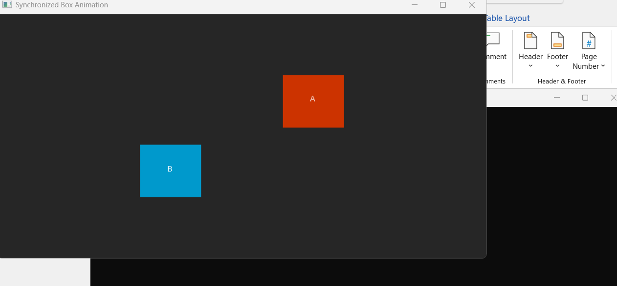

Question-2
Design a car which will have rotating wheels.

Graph Plot (Picture)-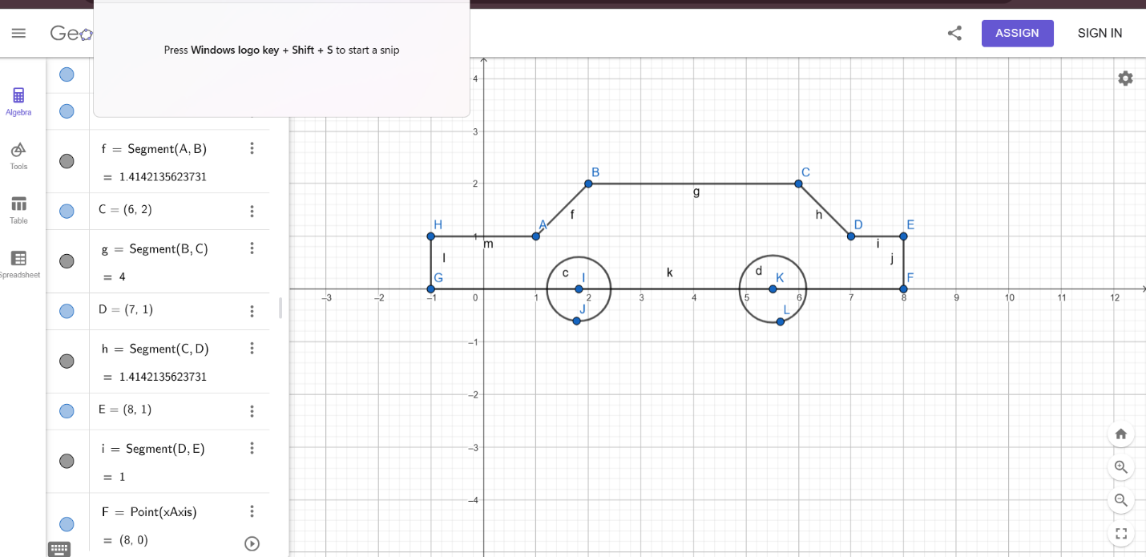

Code-
#include <GL/glut.h>
#include <cmath>

// Car properties
float carX = -8.0f; // Start from left
float carSpeed = 0.05f;
float wheelAngle = 0.0f;

void drawWheel(float x, float y) {
// Wheel rim
glColor3f(0.0f, 0.0f, 0.0f);
glBegin(GL_POLYGON);
for(int i = 0; i < 360; i++) {
float angle = i * 3.14159f / 180.0f;
glVertex2f(x + 0.3f * cos(angle), y + 0.3f * sin(angle));
}
glEnd();

// Rotating spokes
glColor3f(0.5f, 0.5f, 0.5f);
glPushMatrix();
glTranslatef(x, y, 0.0f);
glRotatef(wheelAngle, 0.0f, 0.0f, 1.0f);
for(int i = 0; i < 4; i++) {
glBegin(GL_LINES);
glVertex2f(0.0f, 0.0f);
glVertex2f(0.3f * cos(i * 90 * 3.14159f / 180.0f),
0.3f * sin(i * 90 * 3.14159f / 180.0f));
glEnd();
}
glPopMatrix();
}

void drawCar() {
// Car body
glColor3f(0.8f, 0.2f, 0.2f); // Red color
glBegin(GL_POLYGON);
glVertex2f(carX - 1.5f, 0.0f);
glVertex2f(carX + 1.5f, 0.0f);
glVertex2f(carX + 1.5f, 0.8f);
glVertex2f(carX - 1.5f, 0.8f);
glEnd();

// Car top
glBegin(GL_POLYGON);
for(int i = 0; i < 180; i++) {
float angle = i * 3.14159f / 180.0f;
glVertex2f(carX + 1.0f * cos(angle), 0.8f + 0.5f * sin(angle));
}
glEnd();

// Windows
glColor3f(0.7f, 0.9f, 1.0f);
glBegin(GL_POLYGON);
glVertex2f(carX - 1.0f, 0.2f);
glVertex2f(carX + 1.0f, 0.2f);
glVertex2f(carX + 0.8f, 0.7f);
glVertex2f(carX - 0.8f, 0.7f);
glEnd();

// Wheels
drawWheel(carX - 1.0f, 0.0f);
drawWheel(carX + 1.0f, 0.0f);
}

void display() {
glClear(GL_COLOR_BUFFER_BIT);

drawCar();

glutSwapBuffers();
}

void update(int value) {
// Move car straight along the x-axis
carX += carSpeed;
if(carX > 10.0f) {
carX = -10.0f; // Reset car to the left when it moves off the right side
}

// Rotate wheels forward
wheelAngle += carSpeed * 50;
if(wheelAngle > 360.0f) wheelAngle -= 360.0f;

glutPostRedisplay();
glutTimerFunc(16, update, 0);
}

void init() {
glClearColor(0.0f, 0.0f, 0.0f, 1.0f); // Set background color to black
glMatrixMode(GL_PROJECTION);
glLoadIdentity();
gluOrtho2D(-10.0, 10.0, -5.0, 5.0);
}

int main(int argc, char** argv) {
glutInit(&argc, argv);
glutInitDisplayMode(GLUT_DOUBLE | GLUT_RGB);
glutInitWindowSize(800, 400);
glutCreateWindow("Straight Moving Car");

init();
glutDisplayFunc(display);
glutTimerFunc(0, update, 0);
glutMainLoop();

return 0;
}

Output Screenshot (Full Screen)-

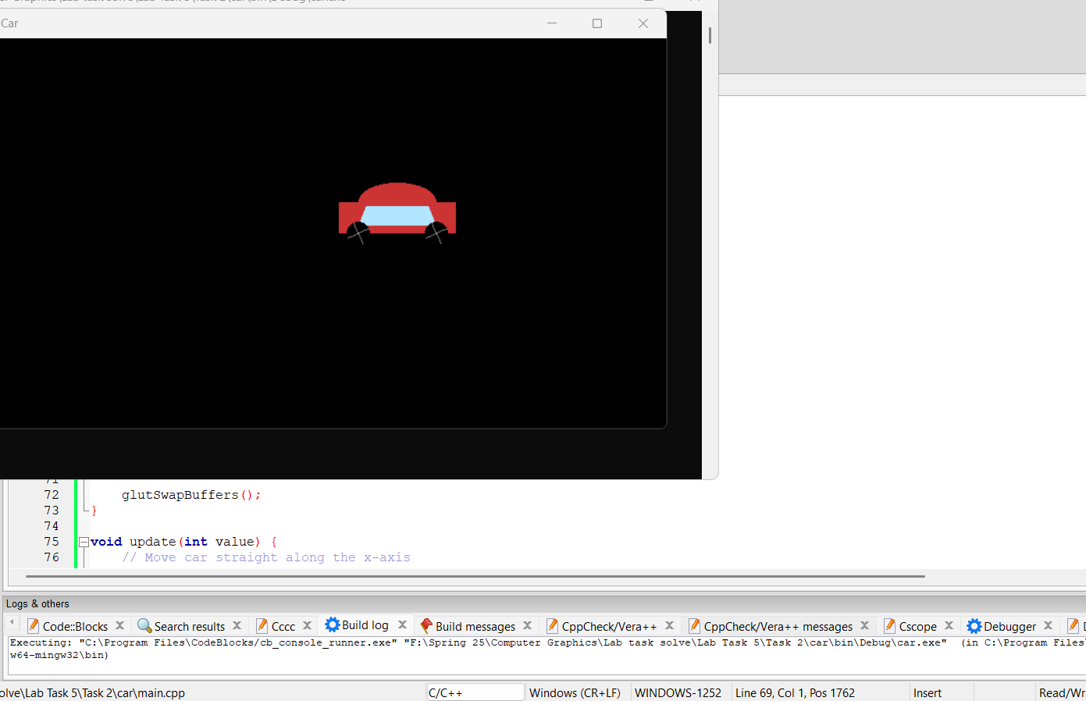

Question-3
Now move your car of question-2 from left to right in a loop.

Graph Plot (Picture)-

Code-
#include <GL/glut.h>
#include <cmath>

// Car properties
float carX = -8.0f; // Start from left
float carSpeed = 0.05f;
float wheelAngle = 0.0f;
bool moveRight = true;

void drawWheel(float x, float y) {
// Wheel rim
glColor3f(0.0f, 0.0f, 0.0f);
glBegin(GL_POLYGON);
for(int i = 0; i < 360; i++) {
float angle = i * 3.14159f / 180.0f;
glVertex2f(x + 0.3f * cos(angle), y + 0.3f * sin(angle));
}
glEnd();

// Rotating spokes
glColor3f(0.5f, 0.5f, 0.5f);
glPushMatrix();
glTranslatef(x, y, 0.0f);
glRotatef(wheelAngle, 0.0f, 0.0f, 1.0f);
for(int i = 0; i < 4; i++) {
glBegin(GL_LINES);
glVertex2f(0.0f, 0.0f);
glVertex2f(0.3f * cos(i * 90 * 3.14159f / 180.0f),
0.3f * sin(i * 90 * 3.14159f / 180.0f));
glEnd();
}
glPopMatrix();
}

void drawCar() {
// Car body
glColor3f(0.8f, 0.2f, 0.2f); // Red color
glBegin(GL_POLYGON);
glVertex2f(carX - 1.5f, 0.0f);
glVertex2f(carX + 1.5f, 0.0f);
glVertex2f(carX + 1.5f, 0.8f);
glVertex2f(carX - 1.5f, 0.8f);
glEnd();

// Car top
glBegin(GL_POLYGON);
for(int i = 0; i < 180; i++) {
float angle = i * 3.14159f / 180.0f;
glVertex2f(carX + 1.0f * cos(angle), 0.8f + 0.5f * sin(angle));
}
glEnd();

// Windows
glColor3f(0.7f, 0.9f, 1.0f);
glBegin(GL_POLYGON);
glVertex2f(carX - 1.0f, 0.2f);
glVertex2f(carX + 1.0f, 0.2f);
glVertex2f(carX + 0.8f, 0.7f);
glVertex2f(carX - 0.8f, 0.7f);
glEnd();

// Wheels
drawWheel(carX - 1.0f, 0.0f);
drawWheel(carX + 1.0f, 0.0f);
}

void display() {
glClear(GL_COLOR_BUFFER_BIT);

// Road background
glColor3f(0.3f, 0.3f, 0.3f); // Gray road
glBegin(GL_POLYGON);
glVertex2f(-10.0f, -2.0f);
glVertex2f(10.0f, -2.0f);
glVertex2f(10.0f, 0.0f);
glVertex2f(-10.0f, 0.0f);
glEnd();

// Grass background
glColor3f(0.0f, 0.5f, 0.0f);
glBegin(GL_POLYGON);
glVertex2f(-10.0f, -5.0f);
glVertex2f(10.0f, -5.0f);
glVertex2f(10.0f, -2.0f);
glVertex2f(-10.0f, -2.0f);
glEnd();

// Sky background
glColor3f(0.6f, 0.8f, 1.0f);
glBegin(GL_POLYGON);
glVertex2f(-10.0f, 0.0f);
glVertex2f(10.0f, 0.0f);
glVertex2f(10.0f, 5.0f);
glVertex2f(-10.0f, 5.0f);
glEnd();

drawCar();

glutSwapBuffers();
}

void update(int value) {
// Move car straight only
if(moveRight) {
carX += carSpeed;
if(carX > 10.0f) {
carX = -10.0f; // Reset to left when exits right
}
}

// Rotate wheels forward only
wheelAngle += carSpeed * 50;
if(wheelAngle > 360.0f) wheelAngle -= 360.0f;

glutPostRedisplay();
glutTimerFunc(16, update, 0);
}

void init() {
glClearColor(1.0f, 1.0f, 1.0f, 1.0f);
glMatrixMode(GL_PROJECTION);
glLoadIdentity();
gluOrtho2D(-10.0, 10.0, -5.0, 5.0);
}

int main(int argc, char** argv) {
glutInit(&argc, argv);
glutInitDisplayMode(GLUT_DOUBLE | GLUT_RGB);
glutInitWindowSize(800, 400);
glutCreateWindow("Straight Moving Car");

init();
glutDisplayFunc(display);
glutTimerFunc(0, update, 0);
glutMainLoop();

return 0;
}

Output Screenshot (Full Screen)-
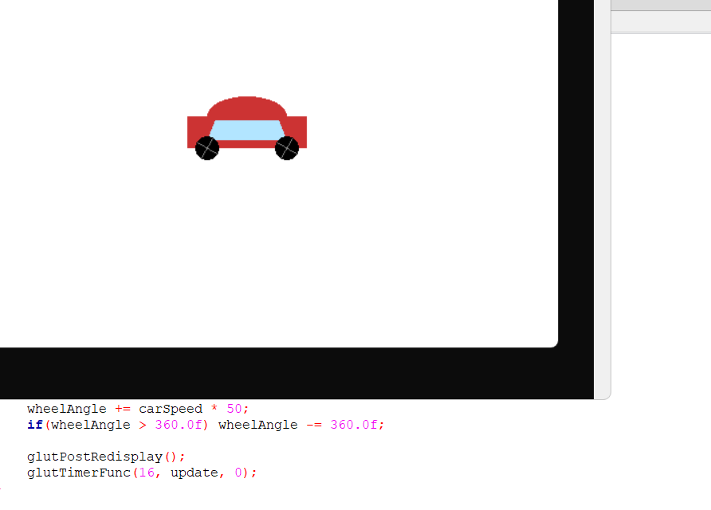

Question-4
Design a windmill with rotating blades

Graph Plot (Picture)-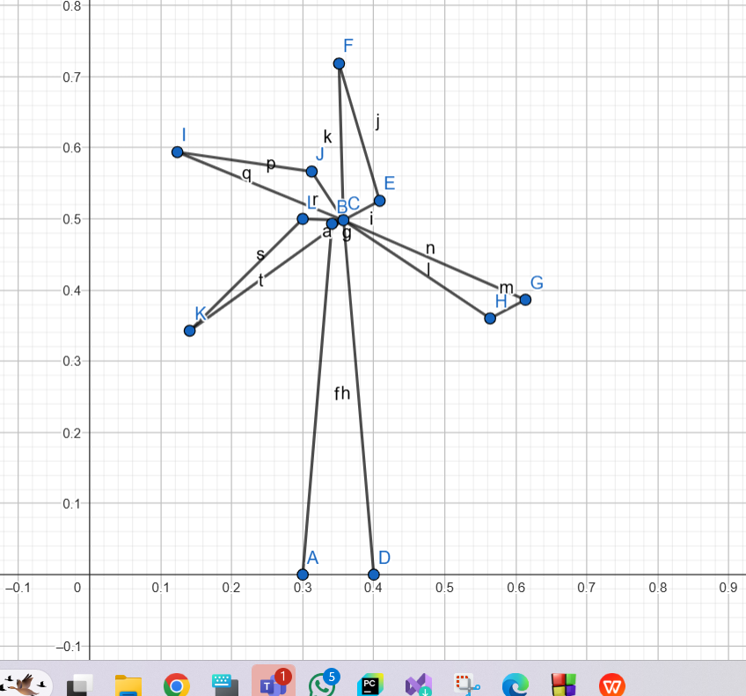

Code-
#include <GL/glut.h>
#include <cmath>

// Windmill parameters
float bladeAngle = 0.0f;
float rotationSpeed = 2.0f; // Faster rotation
const int NUM_BLADES = 4; // 4 blades (pakha)

void init() {
glClearColor(1.0f, 1.0f, 1.0f, 1.0f); // White background
glMatrixMode(GL_PROJECTION);
gluOrtho2D(-1.0, 1.0, -1.0, 1.0);
}

void drawWindmill() {
// Draw tower (brown rectangle)
glColor3f(0.55f, 0.27f, 0.07f); // Brown
glBegin(GL_QUADS);
glVertex2f(-0.03f, -1.0f);
glVertex2f(0.03f, -1.0f);
glVertex2f(0.03f, 0.0f);
glVertex2f(-0.03f, 0.0f);
glEnd();

// Draw hub (center circle)
glColor3f(0.3f, 0.3f, 0.3f); // Dark gray
glBegin(GL_POLYGON);
for(int i = 0; i < 360; i++) {
float degInRad = i * M_PI/180.0f;
glVertex2f(cos(degInRad)*0.08, sin(degInRad)*0.08 + 0.1f);
}
glEnd();

// Draw 4 rotating blades (pakha)
glColor3f(0.5f, 0.5f, 0.8f); // Light blue blades
for(int i = 0; i < NUM_BLADES; i++) {
float angle = bladeAngle + i * (360.0f/NUM_BLADES);
float rad = angle * M_PI / 180.0f;

// Each blade is a quadrilateral
glBegin(GL_QUADS);
// Base near hub
glVertex2f(cos(rad)*0.08, sin(rad)*0.08 + 0.1f);
glVertex2f(cos(rad + 7)*0.08, sin(rad + 7)*0.08 + 0.1f);
// Tip of blade
glVertex2f(cos(rad + 7)*0.7, sin(rad + 7)*0.7 + 0.1f);
glVertex2f(cos(rad)*0.7, sin(rad)*0.7 + 0.1f);
glEnd();
}
}

void display() {
glClear(GL_COLOR_BUFFER_BIT);

drawWindmill();

glutSwapBuffers();
}

void update(int value) {
bladeAngle += rotationSpeed;
if(bladeAngle > 360) bladeAngle -= 360;

glutPostRedisplay();
glutTimerFunc(16, update, 0); // ~60 FPS
}

int main(int argc, char** argv) {
glutInit(&argc, argv);
glutInitDisplayMode(GLUT_DOUBLE | GLUT_RGB);
glutInitWindowSize(600, 600);
glutCreateWindow("4-Blade Windmill (Pakha)");

init();
glutDisplayFunc(display);
glutTimerFunc(25, update, 0);

glutMainLoop();
return 0;
}

Output Screenshot (Full Screen)-
